**DCL COMMANDS**

GRANT SELECT ON BANK TO C22CSA45;

SELECT * FROM C22CSA45.BANK_TABLE;

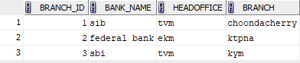

UPDATE C22CSA45.BANK_TABLE SET BRANCH = 'PALAI' WHERE BRANCH_ID = 1;

COMMIT;

SELECT * FROM C22CSA45.BANK_TABLE;

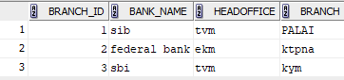

UPDATE C22CSA45.BANK_TABLE SET BRANCH = 'KATTAPANA' WHERE BRANCH_ID = 2;

COMMIT;

SELECT * FROM C22CSA45.BANK_TABLE;

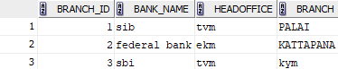

UPDATE C22CSA45.BANK_TABLE SET BRANCH = 'KOTTAYAM' WHERE BRANCH_ID = 3;

COMMIT;

SELECT * FROM C22CSA45.BANK_TABLE;

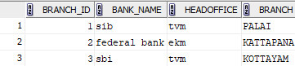

REVOKE SELECT ON BANK FROM C22CSA45;